

**Student Name: Muhammad Abdullah**

**Roll Number: BIT-23F-024**

**Section: IT 3A**

**Department: BS Information Technology**

**Lab: 06**

**Task 01**

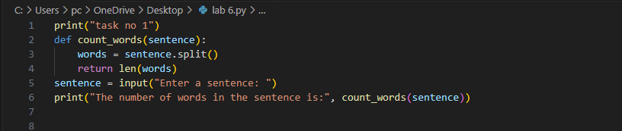

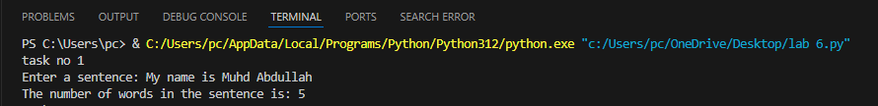

**Task 02**

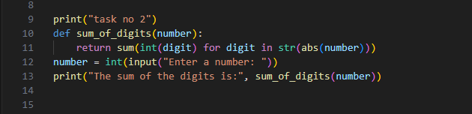



Task 03

